The Distance Formula

*dist((x1, y1), (x2, y2)) = √(x1 –x2)² + (y1 – y2)²*

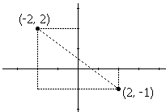

As an example, the (Euclidean) distance between points (2, -1) and (-2, 2) is found to be

|  |  |  |
| --- | --- | --- |
|  | dist((2, -1), (-2, 2)) | = √(2 - (-2))² + ((-1) - 2)² |
|  |  | = √(2 + 2)² + (-1 - 2)² |
|  |  | = √(4)² + (-3)² |
|  |  | = √16 + 9 |
|  |  | = √25 |
|  |  | = 5. |

**Sum all the distances between all points:**





### Add a 2nd dimensions

In the [Euclidean plane](https://en.wikipedia.org/wiki/Euclidean_plane), if **p** = (*p*1, *p*2) and **q** = (*q*1, *q*2) then the distance is given by:



